**Practical – 1**

**Aim : Practice List and String**

1. **Python program to interchange first and last elements in a list**

**Program :**list = [1,3,9,5,10,12,2,6,8]

print(f"List before Interchange : {list}")

list[0],list[-1] = list[-1],list[0]

print(f"List After Interchange : {list}")

**Output :**



1. **Python program to swap two elements in a list**

**Program :**

print(f"List before Interchange : {list}")

x = [int(i) for i in input("Enter Index Space-Separated : ").split(' ')]

list[x[0]],list[x[1]] = list[x[1]],list[x[0]]

print(f"List After Interchange : {list}")

**Output :**



1. **Python | Ways to find length of list**

**Program :**

count = 0

print(f"List : {list}")

print(f"Length of a list is {len(list)} by len function.")

for i in list:

count += 1

print(f"Length of a list is {count} by for loop.")

**Output :**



1. **Maximum of two numbers in Python**

**Program :**

def maxOfTwo(x,y):

if(x >= y):

return x

else:

return y

a = int(input("Enter First number : "))

b = int(input("Enter Second number : "))

print(f"Maximum of two number is {max(a,b)} by max() function.")

print(f"Maximum of two number is {maxOfTwo(a,b)} by maxOfTwo() function.")

**Output :**

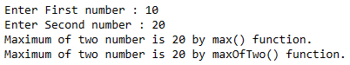

1. **Minimum of two numbers in Python**

**Program :**

def minOfTwo(x,y):

if(x <= y):

return x

else:

return y

a = int(input("Enter First number : "))

b = int(input("Enter Second number : "))

print(f"Minimum of two number is {min(a,b)} by min() function.")

print(f"Minimum of two number is {minOfTwo(a,b)} by minOfTwo() function.")

**Output :**

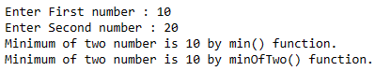

**Python String Exercises**

1. **Python program to check whether the string is Symmetrical or Palindrome**

**Program :**

str1 = "khokho"

def isPalindrome(s):

return s == s[::-1]

def isSymmetric(s):

s1 = s[:len(s)//2]

s2 = s[len(s)//2:]

if s1 == s2:

return True

else:

return False

ans1 = isPalindrome(str1)

ans2 = isSymmetric(str1)

if ans1 == True:

print(f"String : {str1} is Palindrome.")

else:

print(f"String : {str1} is not Palindrome.")

if ans2 == True:

print(f"String : {str1} is Symmetric.")

else:

print(f"String : {str1} is not Symmetric.")

**Output :**



1. **Reverse words in a given String in Python**

**Program :**

string_list = str1.split(' ')

new_string = ''

print("Method - 1 : Using for loop")

for i in range(len(string_list) - 1, -1, -1):

new_string += string_list[i] + ' '

new_string = new_string[:-1]

print(new_string,"\n")

print("Method - 2 : Using Slicing")

new_string = " ".join(string_list[::-1])

print(new_string)

**Output :**

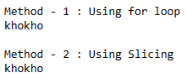

1. **Ways to remove i’th character from string in Python**

**Program :**

print(f"Original String : {str1}")

idx = int(input("Enter an index value : "))

print("Method - 1")

new_string = ''

for i in range(len(str1)):

if i != idx:

new_string += str1[i]

print(f"New String : {new_string}")

print("\nMethod - 2")

new_string = str1[:idx] + str1[idx+1:]

print(f"New String : {new_string}")

**Output :**

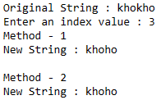

1. **Find length of a string in python (4 ways)**

**Program :**

def find_len1(str_1):

counter = 0

for i in str_1:

counter += 1

return counter

def find_len2(str_1):

return sum( 1 for i in str_1);

def find_len3(str_1):

counter = 0

for i, a in enumerate(str_1):

counter += 1

return counter

print(f"Original String : {str1}\n")

print(f"String length is {find_len1(str1)} using find_len1() function.")

print(f"String length is {find_len2(str1)} using find_len2() function.")

print(f"String length is {find_len3(str1)} using find_len3() function.")

print(f"String length is {len(str1)} using len() function.")

**Output :**

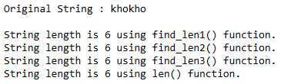

1. **Python program to print even length words in a string**

print(f"Original String : {str1}\n")

print("Here are even words : ")

str_list = str1.split(' ')

for i in range(0,len(str_list),2):

print(str_list[i],end = '\t')

**Output :**

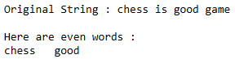

**Calculator - Addition | Subtraction | Multiplication | Division**

**Program :**

def add(num1,num2):

return num1+num2

def sub(num1,num2):

return num1-num2

def mul(num1,num2):

return num1*num2

def div(num1,num2):

return num1/num2

def mod(num1,num2):

return num1%num2

num1 = float(input("Enter first number : "))

num2 = float(input("Enter second number : "))

choice = int(input("1. Addition\n2. Subtraction\n3. Multiplication\n4. Division\n5. Find Reminder\n6. Exit\n\nEnter your choice : "))

if choice == 1:

print(f"Sum of {num1} and {num2} is {add(num1,num2)}.\n")

elif choice == 2:

print(f"Subtraction of {num1} and {num2} is {sub(num1,num2)}.\n")

elif choice == 3:

print(f"Multiplication of {num1} and {num2} is {mul(num1,num2)}.\n")

elif choice == 4:

print(f"Division of {num1} and {num2} is {div(num1,num2)}.\n")

elif choice == 5:

print(f"{num1} % {num2} = {mod(num1,num2)}\n")

elif choice == 6:

exit(0)

else:

print("Invalid Choice !!")

**Output :**

